RSWA v4 Users Guide
Table of Contents
Introduction 1
Affiliating the RSWA with a Data Source 2
Importing Templates and Users 2
Inspections 3
Creating a New Inspection 3
Exiting the Auditor 5
Continuing Active Inspections 6
Viewing Saved Inspections 6
Exporting Inspections 6
Settings 7
Probe Configuration 8
RSWA Configuration 9
File Browser 9
Date and Time 9
Control Panel 10
System Information 11
System Log 11
Wifi 12
Inspection Storage 13
Other Features 13
Thickness Gauge 13
Battery Monitor, Volume, and Brightness 14

Introduction
This document outlines how to use the RSWA software to measure inspections and transfer data to and from your data service.
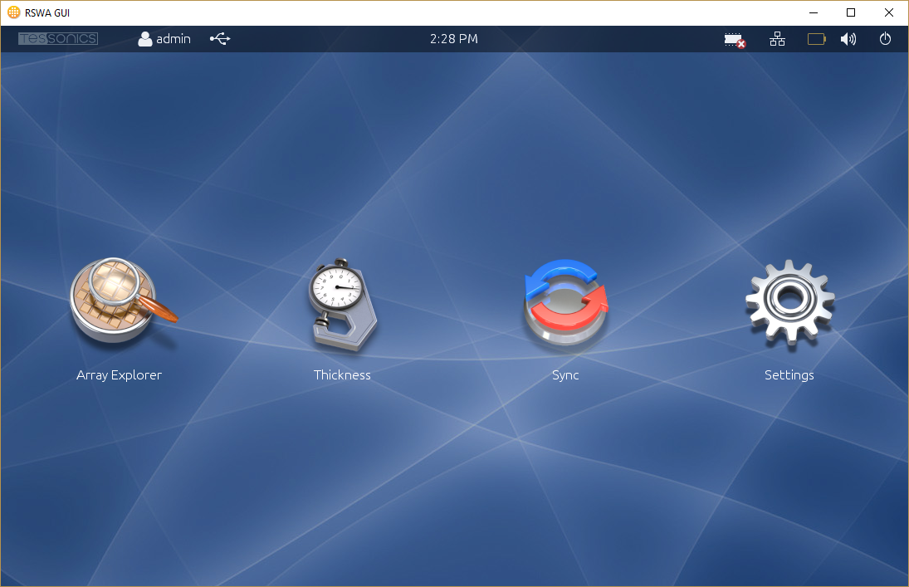
RSWA Desktop

Affiliating the RSWA with a Data Source
When you start the RSWA for the first time, there will not be any templates or users installed, and you will not have access to the wifi functionality. You must first affiliate the RSWA with a data source. To do that, create a template revision using the Desktop Tools application, and export it to a USB key. Afterward, insert the USB key into the RSWA, and click “Sync”, then “Import Templates”. You will see the template revision listed on the page. Click it to activate it. Afterward, this RSWA will be affiliated with the data source that the revision came from, and you will see your templates and users. Also, you will be able to push inspections from the RSWA via wifi.

Importing Templates and Users
Importing updated templates and users involves the same process as the initial affiliation. The difference is that, unlike when you affiliated the RSWA for the first time, you now have the ability to import templates and users onto the RSWA wirelessly from the Desktop Tools. If you wish to continue using the USB key method, then the steps are identical to those in the previous section.

Inspections

Creating a New Inspection
When starting a new inspection, you are given a choice between three inspection modes: Part, Containment, and Custom.
- Part Inspections
- Part inspections are inspections that measure the welds of a specific part in your products catalogue. Parts can have many different routes, and each part inspection must follow a route. When starting a part inspection, you will be asked to select which part and route to inspect.
- Containment Inspections
- Containment Inspections, like Part Inspections, inspect a single route of a part. However, unlike Part Inspections, Containment Inspections allow you to select only the welds that have come from a specific set of robots. This is useful in situations where there are many welds in a route, but you are only interested in inspecting the welds that belong to a particular robot.
- Custom Inspections
- Custom Inspections are not correlated to parts in any way. When starting a custom inspection you will be asked what type of material you will be inspecting. In all other cases the material is determined by the part you select.
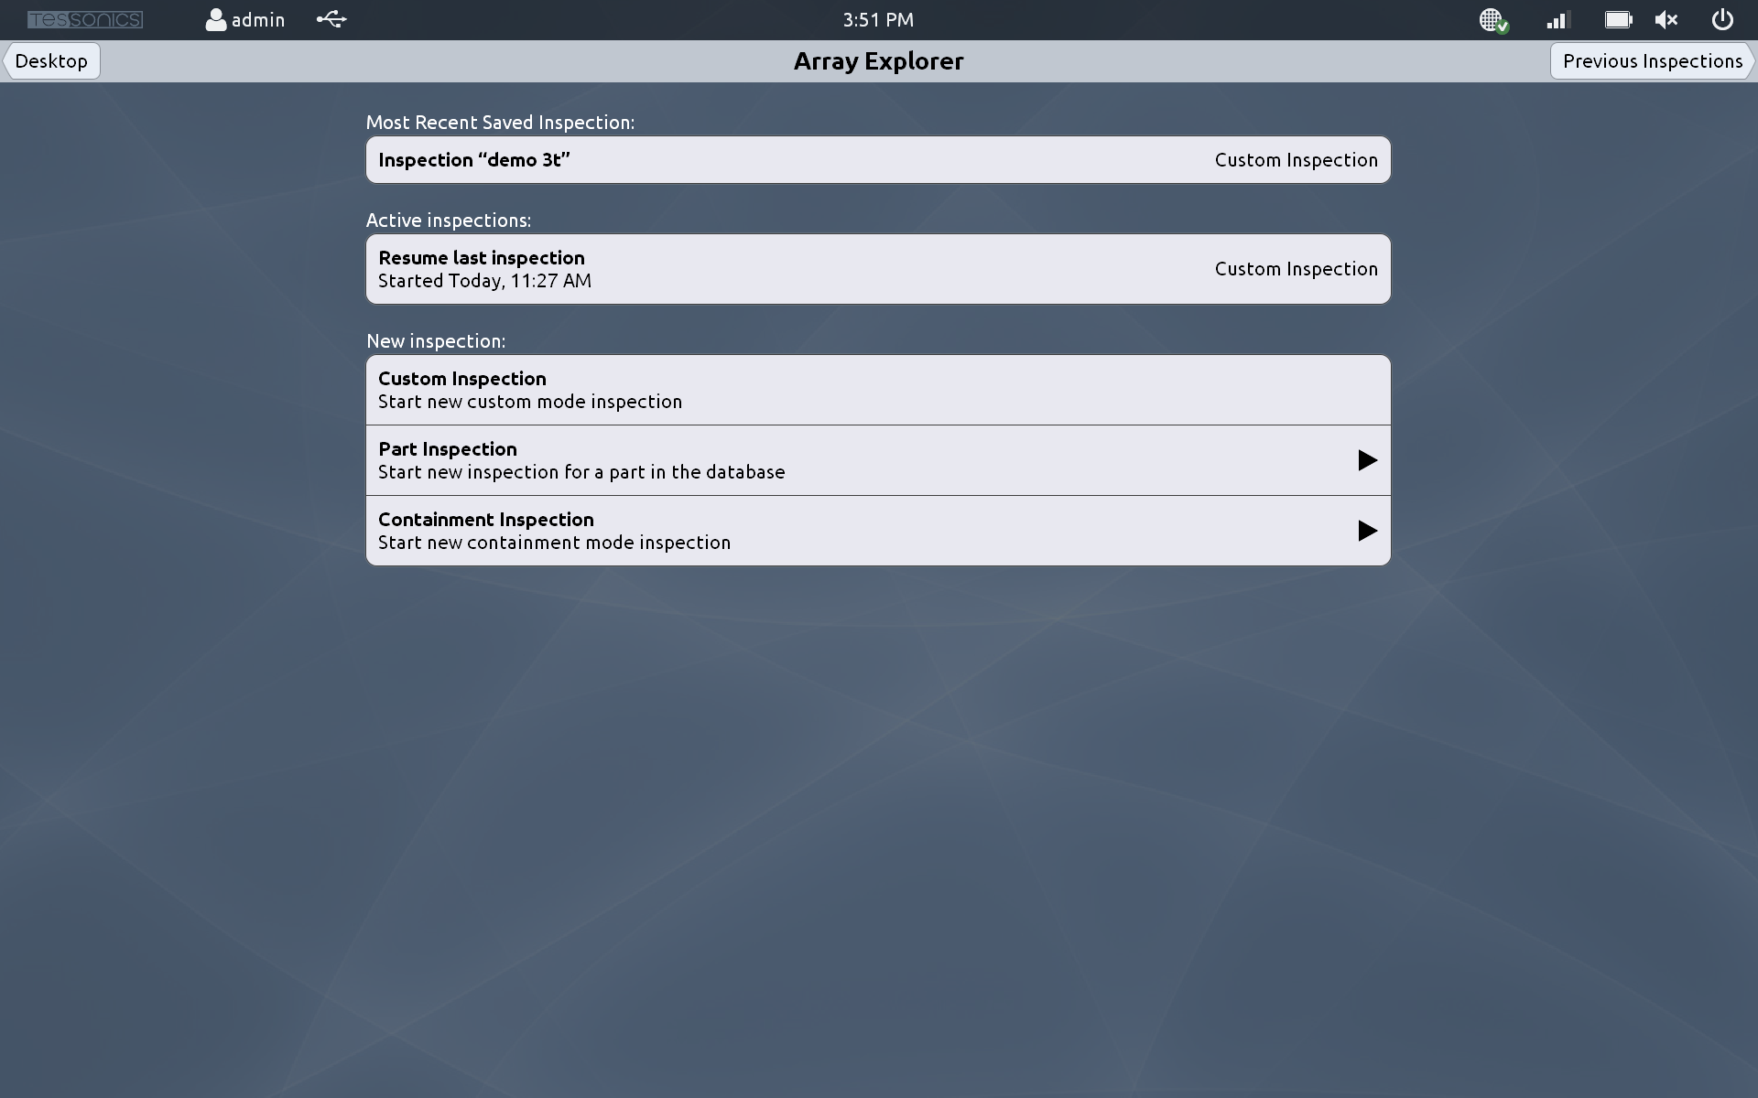
Creating a new inspection
Once you have selected the kind of inspection you are going to undertake, you will be taken to the Auditor screen.
Along the left hand side of the Array Explorer screen, you will see five buttons:
- SETUP
- Perform a setup operation. This should be done on an area of the material that does not contain a hotspot.
- GET
- Acquire a measurement. In a custom inspection, the measurement will be added to the measurements list. For a part inspection or containment inspection, the measurement will be assigned to the currently selected hotspot in the part list.
- PASS
- Pass a measurement, indicating that this measurement is of good quality.
- FAIL
- Fail a measurement, indicating that this measurement is bad. You will be prompted for a failure reason. Common reasons for spot welds are: too small, cold, not in the right location, etc. You also have the option of inputting a custom reason for failure.
- NEXT
- Move to the next hotspot in the list. For a part inspection or containment inspection, this moves to the next hotspot in the selected route. For custom inspections, it moves to the next hotspot in the hotspot list, creating a new hotspot in the list if necessary.
These five controls cover the majority of what it takes to create an inspection with the RSWA.
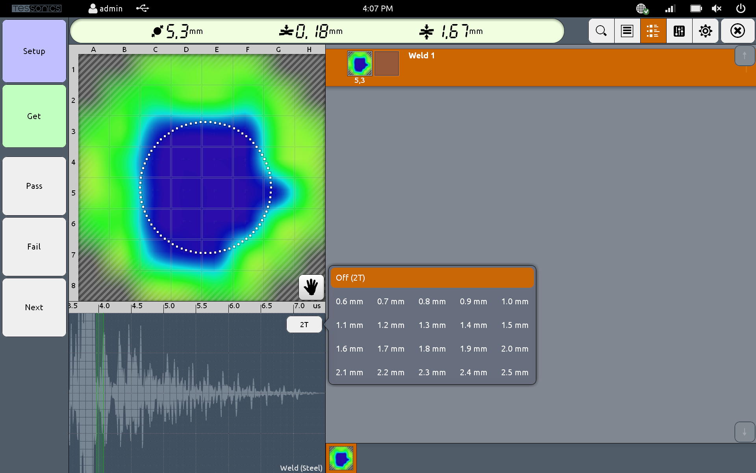
The main Array Explorer screen

Exiting the Auditor
To exit an inspection, click the X button in the top-right of the screen. You will be asked to save the inspection, keep it active, or delete it.
- Save Inspection
- The inspection will be saved to permanent storage, and will then be ready to export to the TDS server. Saved inspections can not be edited.
- Keep Inspection Active
- This will save the inspection in its current state, but will allow for future modification. Inspections kept active are not allowed to be exported to the TDS server.
- Delete Inspection
- Do not keep the inspection data on the hard drive of the RSWA. Deleted inspections cannot be restored.
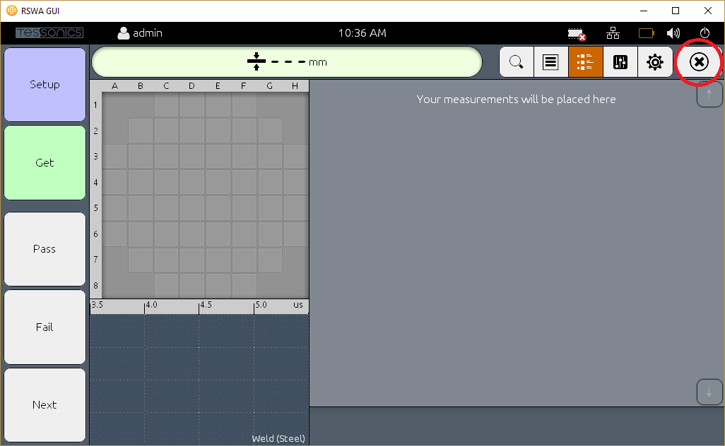
Finishing an inspection
Once you have made your choice, the inspection applet will close and you will be taken back to the New Inspection screen.

Continuing Active Inspections
When you exit the auditor you have the option of keeping your inspection active. This allows you to resume the inspection at a later time. To resume an active inspection, click on the Array Explorer icon from the main page. You will see a list of the active inspections. Click the one you wish to continue and you will be brought back into the auditor page.

Viewing Saved Inspections
Once an inspection is saved, it is no longer editable. However you can still view saved inspections to view the measurements etc.

Exporting Inspections
Exporting completed inspections, like importing templates, can be done either via Wifi, or by USB stick.
To export your inspections, click Sync, then Export Inspections. You will be brought to a page where you will be able to select the inspections you wish to export, or choose the option “Export Recommended” to select all inspections that have not yet been exported from the RSWA.
Once you have selected the inspections to export, you will be given the option to either export them to a USB stick, or to the data server. If your RSWA is connected to the wireless network, it is strongly recommended to export directly to the server. Otherwise, select the USB stick from the list, and click “Export”. You will then need to eject that USB stick and insert it into a computer running the Desktop Tools to complete the export operation.
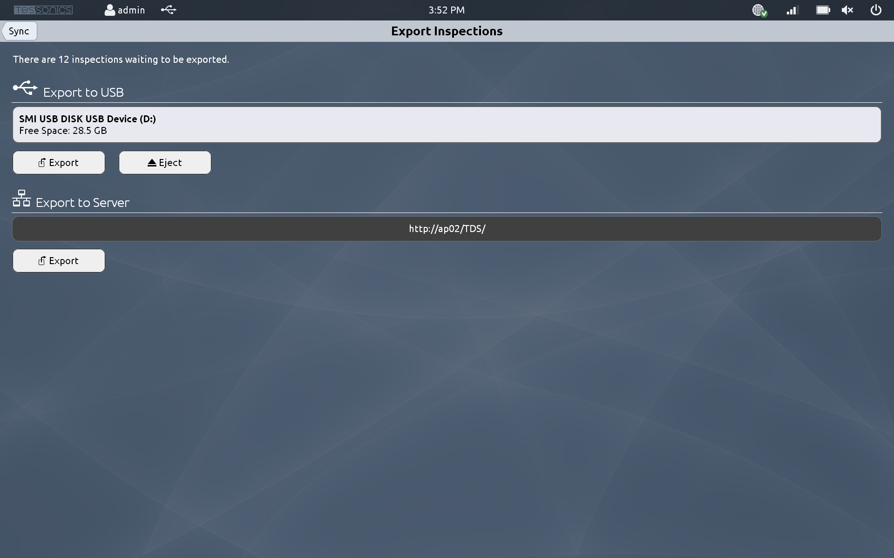
Exporting Inspections
If you do not wish to export inspections manually, there is an option to allow the RSWA to attempt to export your inspections as soon as you have saved them to permanent storage. To enable this feature, from the main page, click Settings, then RSWA Configuration. Turn on the setting “Export Inspections on Save”.
To remain on the safe side, if an inspection cannot be exported wireless for whatever reason, it is not removed from the RSWA. You are always able to export it via USB.

Settings
The Settings application provides access to settings, system information, and more.
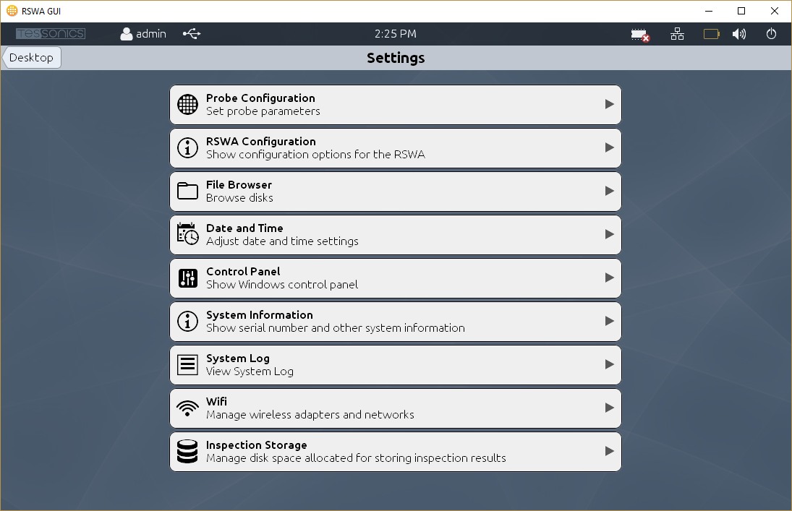
Settings

Probe Configuration
Configure your ultrasonic probe. This page allows you to adjust settings related to your ultrasonic probe. In most cases, the Auto Setup action should be sufficient for operating your RSWA.
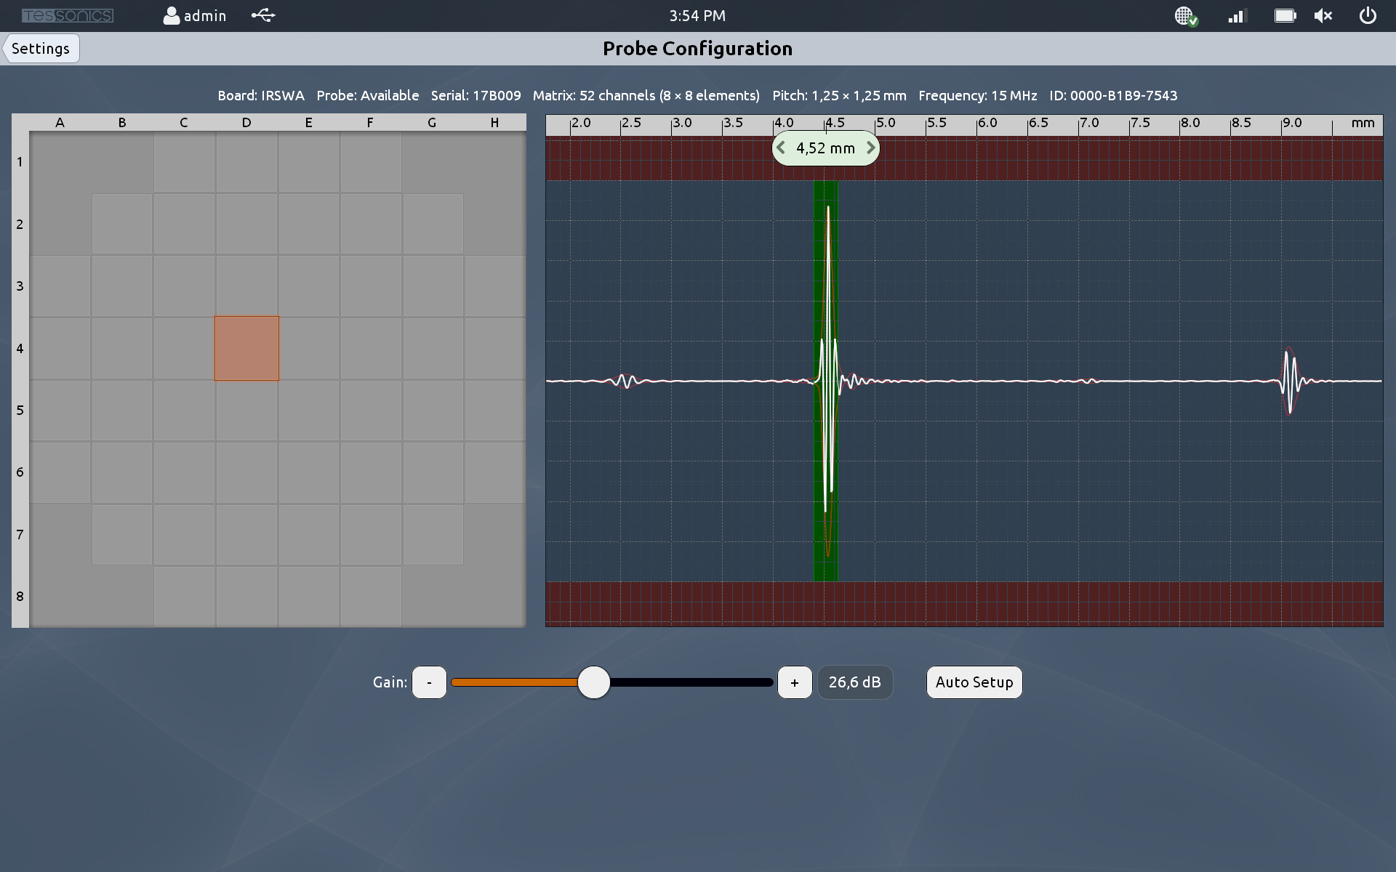
Probe Configuration

RSWA Configuration
Settings related to the operation of your RSWA.

File Browser
Provides access to the file system on the RSWA as if it were a standard PC.

Date and Time
Adjust date and time settings for the RSWA.
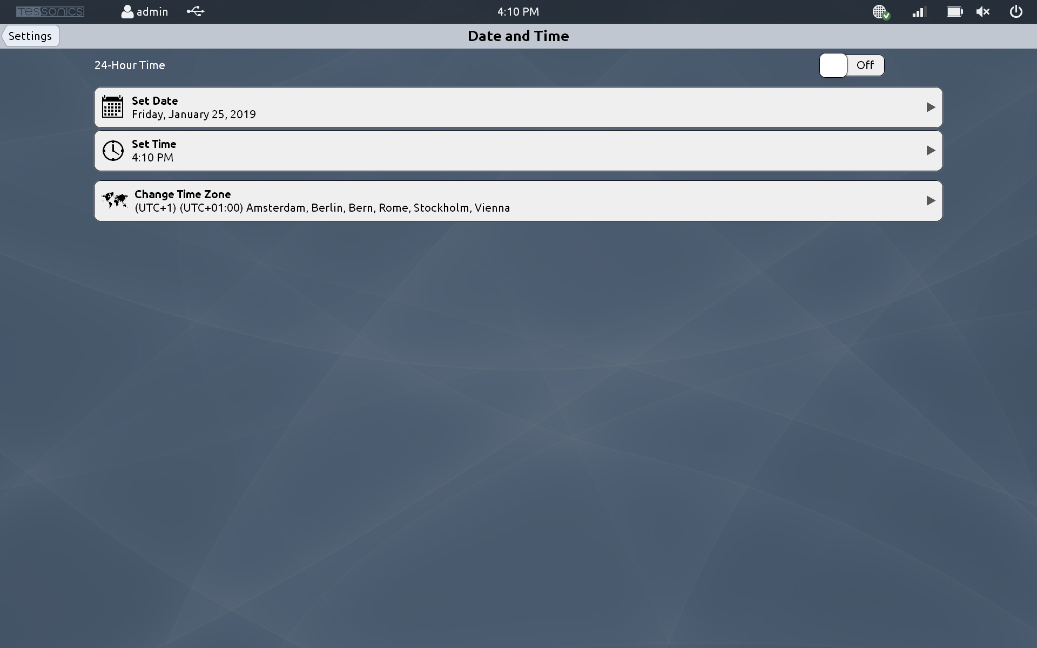
Date and Time

Control Panel
Provides access to the Windows Control Panel. This is for advanced users only.
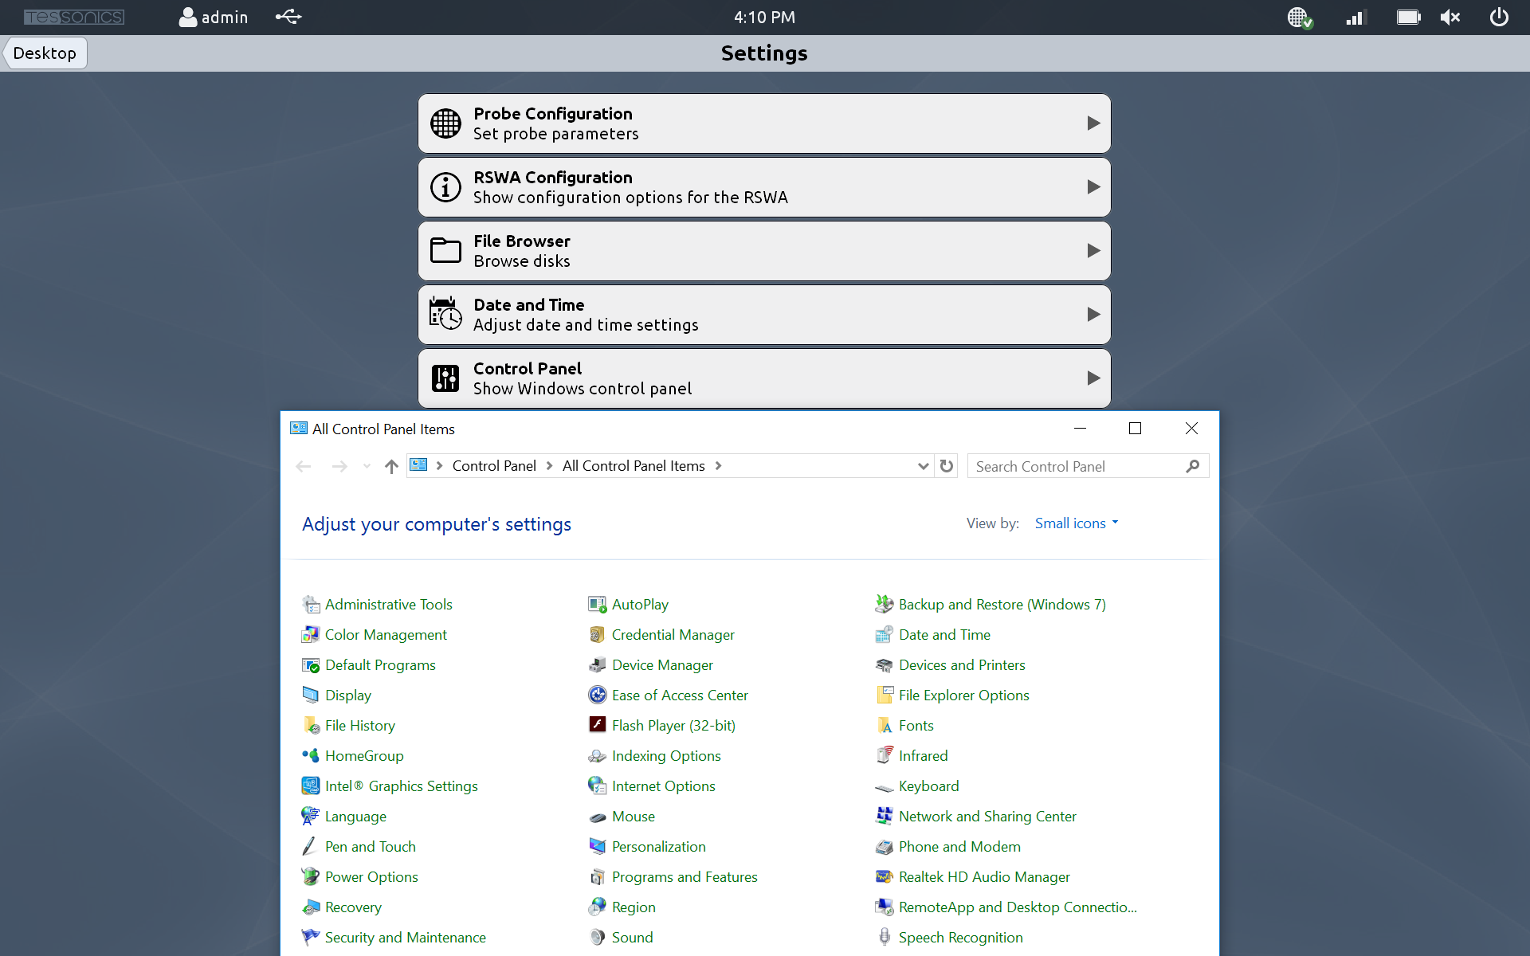
Control Panel

System Information
Show information related to your RSWA, including the software version, licensing information, and hardware information.
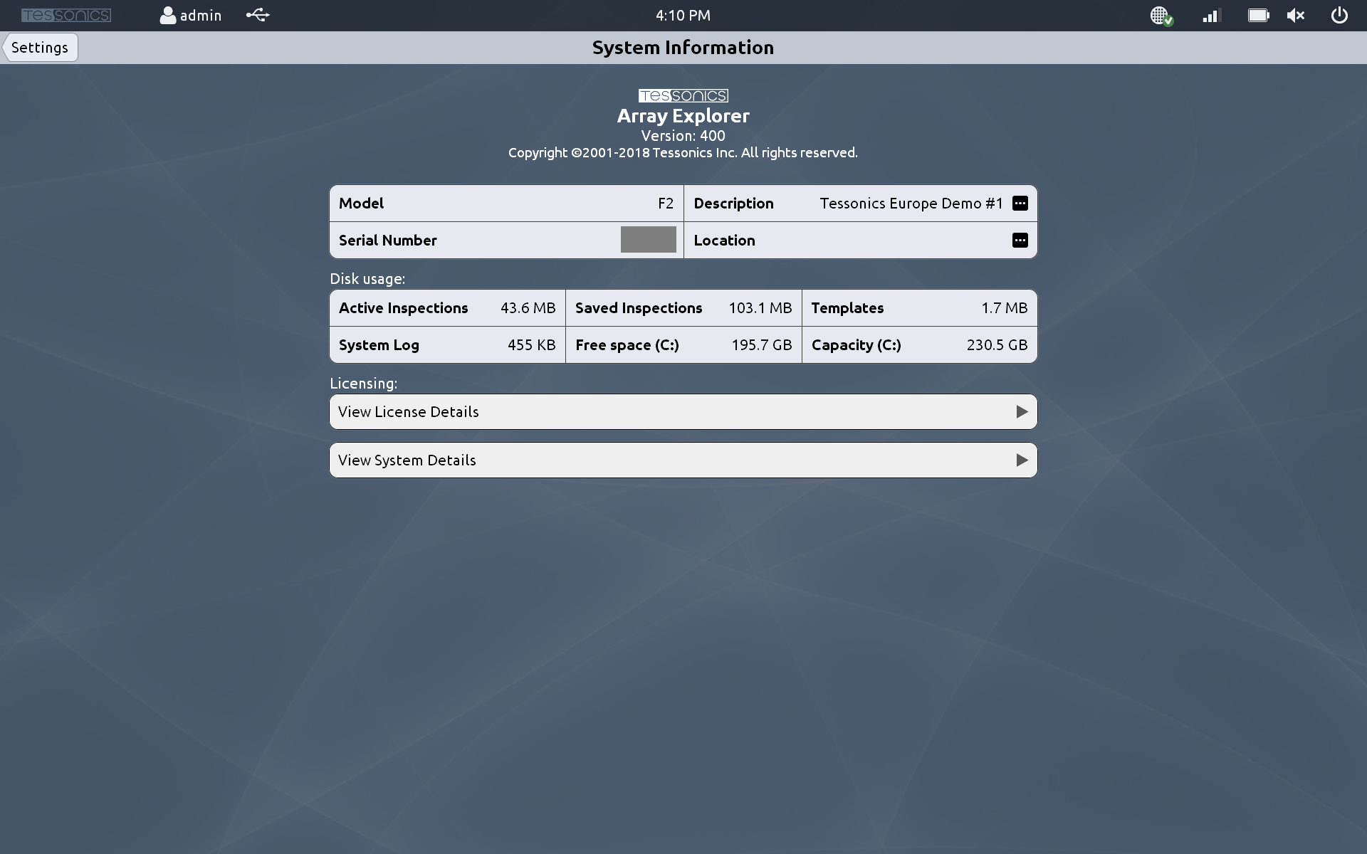
System Information

System Log
Provides access to the RSWA activity log.
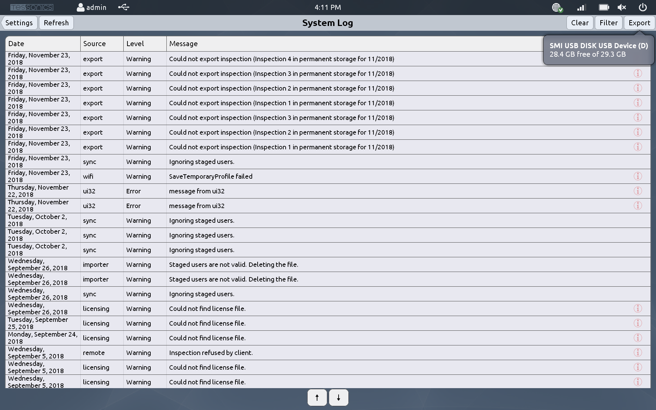
System Log

Wifi
Adjust wifi settings so that the RSWA can transfer data wirelessly.
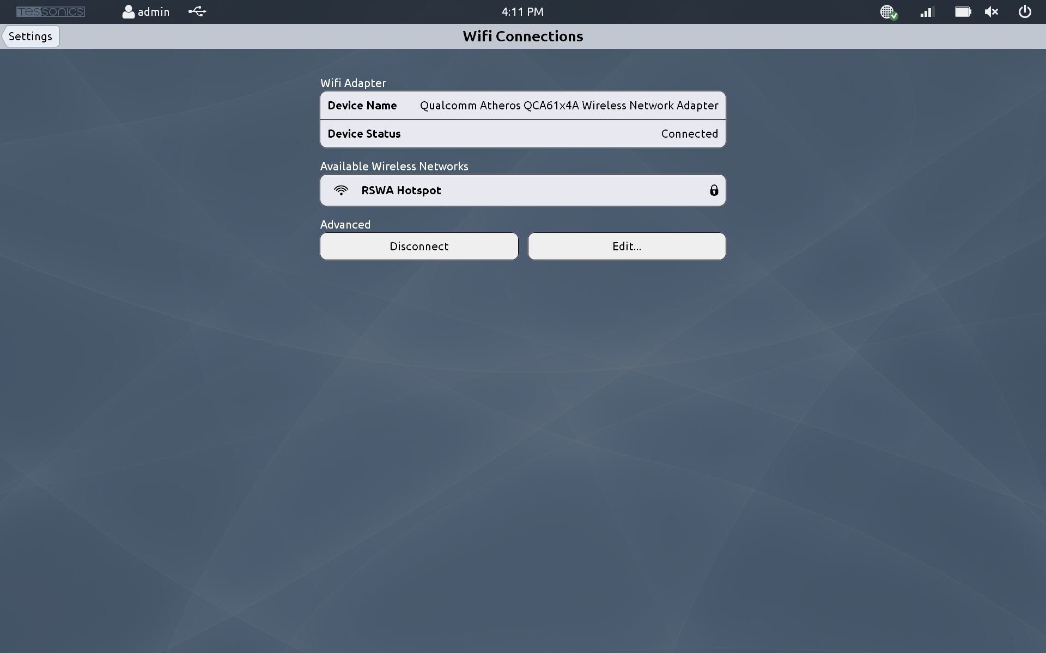
Wifi Configuration

Inspection Storage
View and delete old inspections to free up hard drive space on the RSWA.
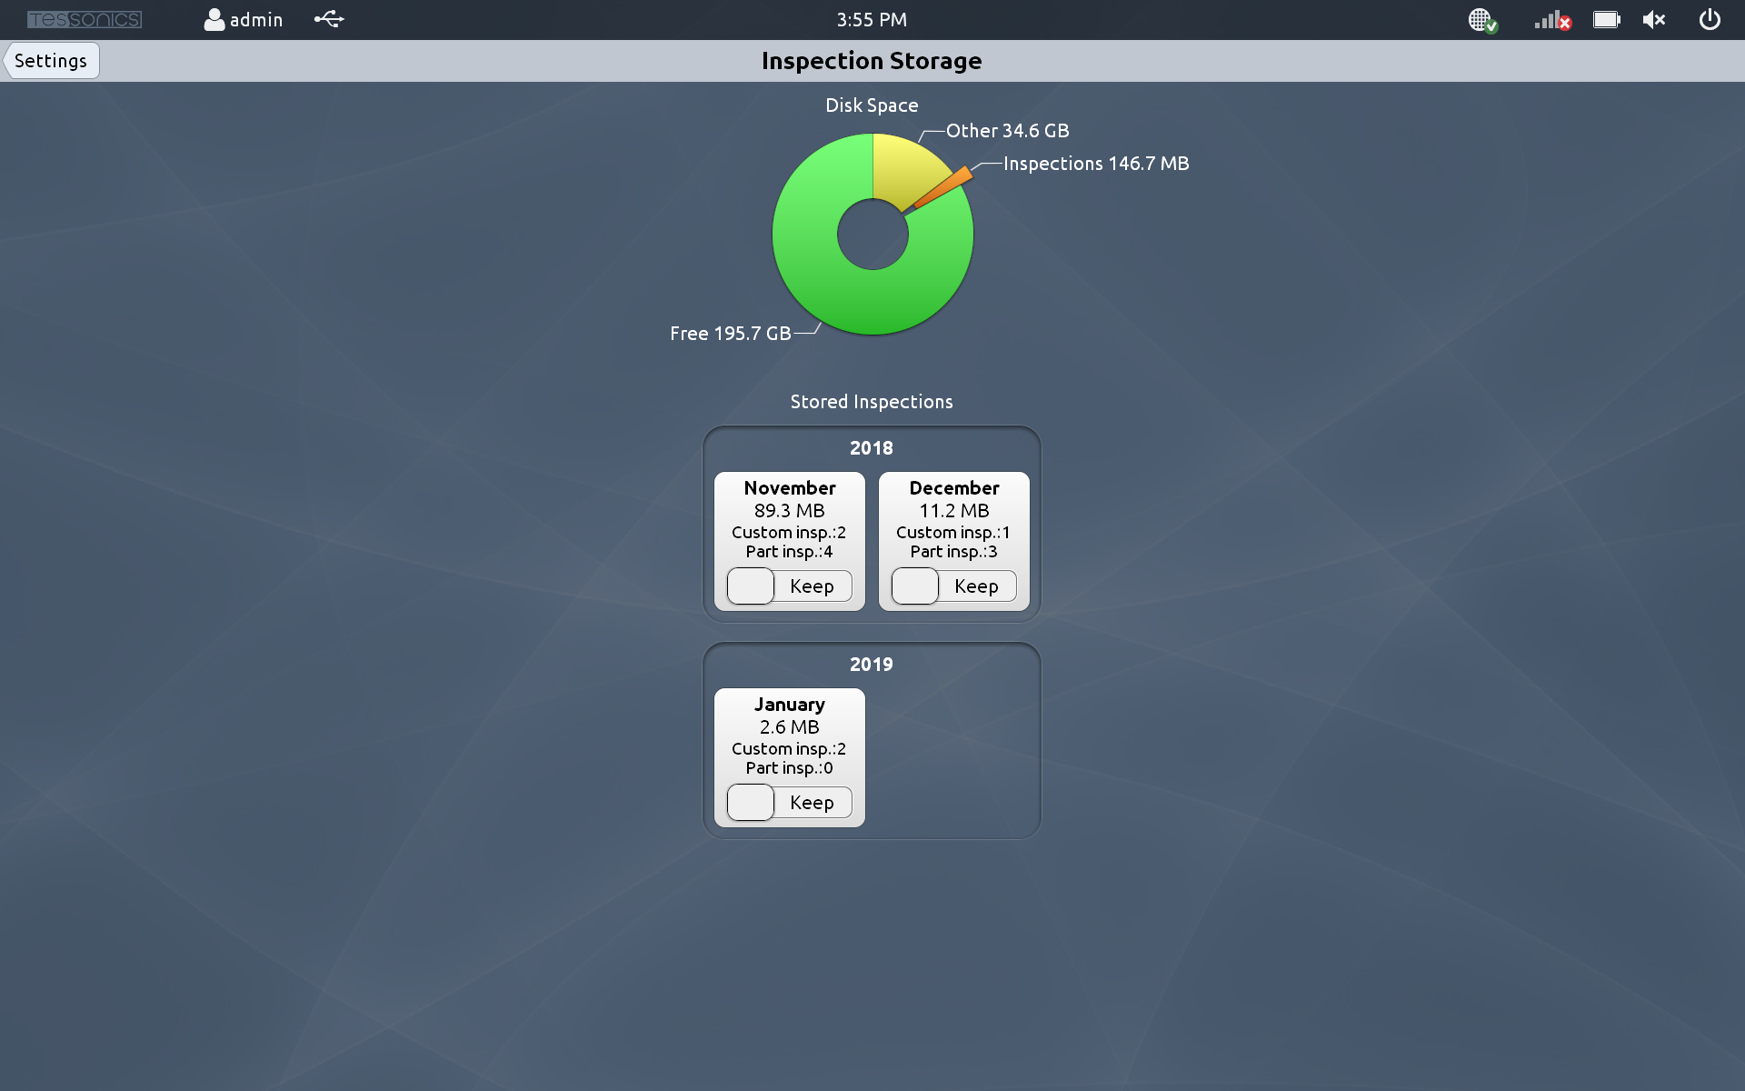
Inspection Storage

Other Features

Thickness Gauge
The Thickness Gauge is a utility for measuring the thickness of a piece of material. Select your material type from the slider below the signal, and then place the probe on the surface. The measured thickness will be shown at the top of the screen.
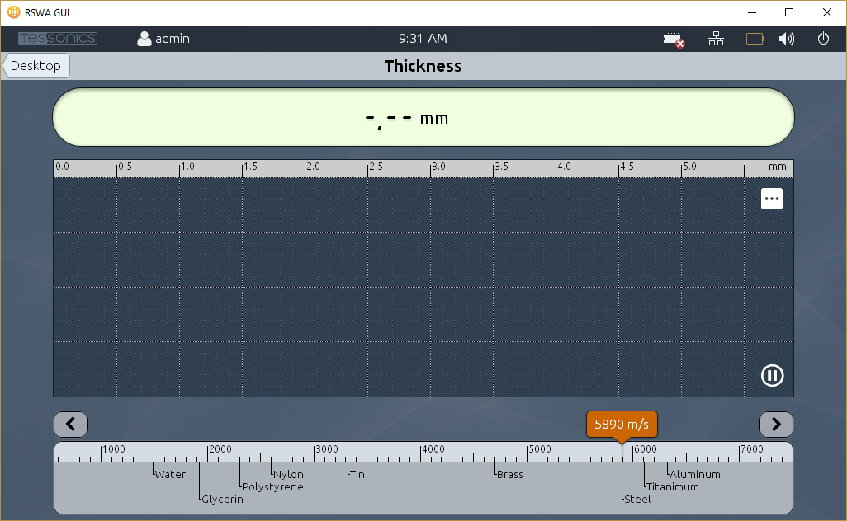
Thickness Gauge

Battery Monitor, Volume, and Brightness
At the top of the RSWA main screen is a small status bar with icons. Clicking on them, you can see the current battery charge status, control the audio volume and screen brightness, and check the communication status with the ultrasonic probe. You can also see the wireless network details by clicking on the Wifi signal icon.
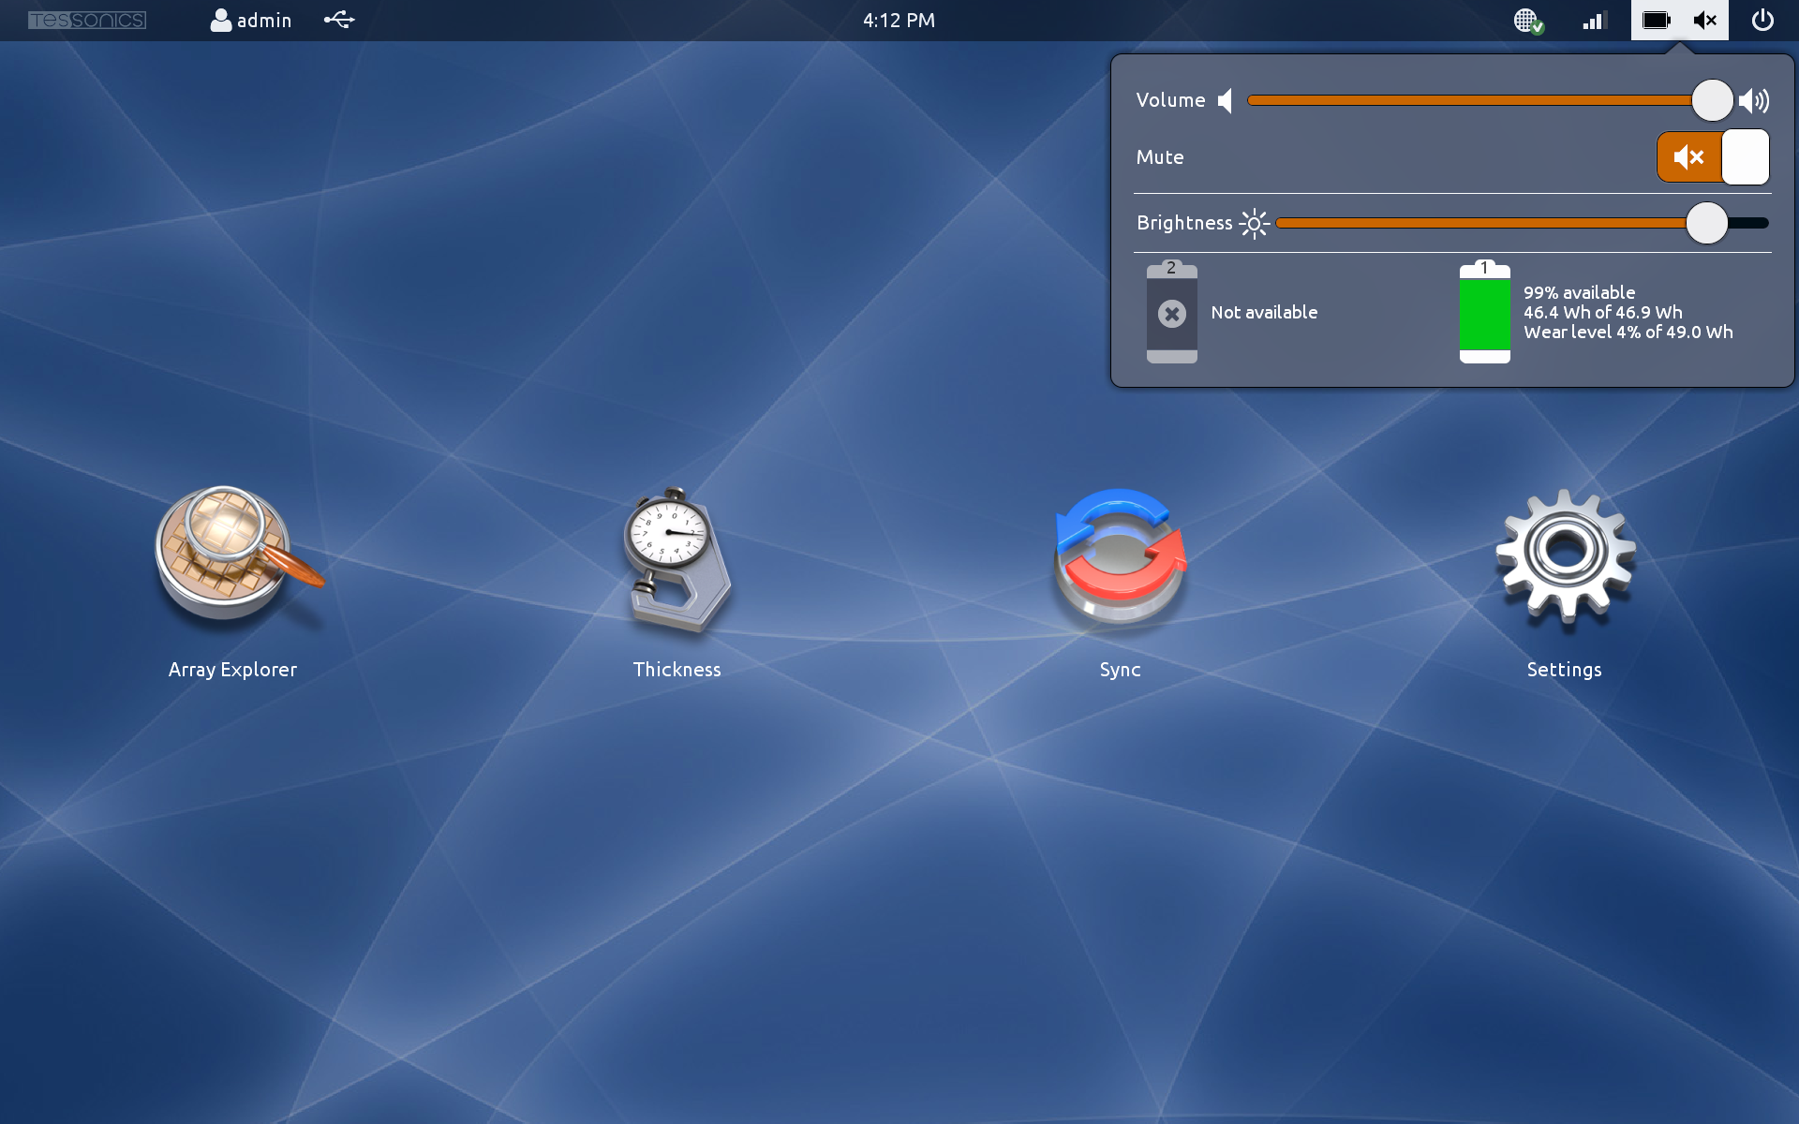
Battery Status

