Table of Contents

title: TDS Server Usage Guide

TDS Server
The Tessonics Data Service (TDS) Server acts as both a repository for inspection data as well as a reporting tool. It is a web-based application, which means it is accessible wherever you have an internet connection, and on any device (e.g. desktop computers, mobile phones, tablets). It works in conjunction with the Desktop Tools for managing RSWA units and the data they generate. TDS works best with a modern internet browser.
At any time, the home page for the server may be accessed by clicking RSWA reporter in the top left of the screen.

User Management
To view and edit RSWA users click the Edit Users link on the homepage or the Users link on the navbar at the top of most pages. In order to access the user manager, you must first log into the server. At any time you may log in or out by clicking the Login or Logout link in the top right corner of the web pages. If no one has ever logged into the server before, the default username is admin and the default password is spotweld.
Only active users in the Administrator group may use the user manager.
The user editor show you the full list of active RSWA users. This include their avatar Image, User Name, Login, Alternative ID, the Groups they are registered in, and the caption, date/time and link to the Last Inspection they performed if any.
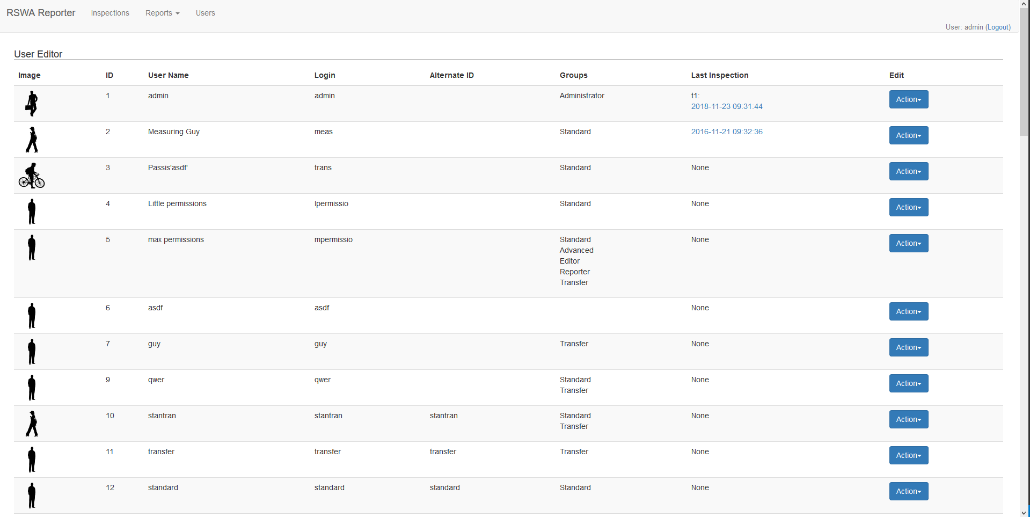
User Editor
At the bottom of this list there are two buttons.

Recycle Bin
The Recycle Bin changes the list to users that have been previously deleted. From this view, you have the option to Restore users if necessary. Click the Back to Editor button at the bottom of the list on this screen to return to the main view.

Creating Users
The Create User button allows for the creation of new users. Clicking it will open a dialog prompting you for information about the new user. The User Name is what is displayed wherever the user is shown. The Login field dictates the username the user will use to login to TDS. The Password and Confirm Password can should be filled out with the user’s password. However, you opt to give the user no password, in which case, the user will only be able to login to RSWA units and not TDS or Desktop Tools. The alternate identifier is purely optional. The groups assigned to a user dictate what action they may perform in the RSWA suite. See the desktop tools documentation for a description of each of the various groups. Finally, you can click Create to create the user or Cancel to close the dialog.
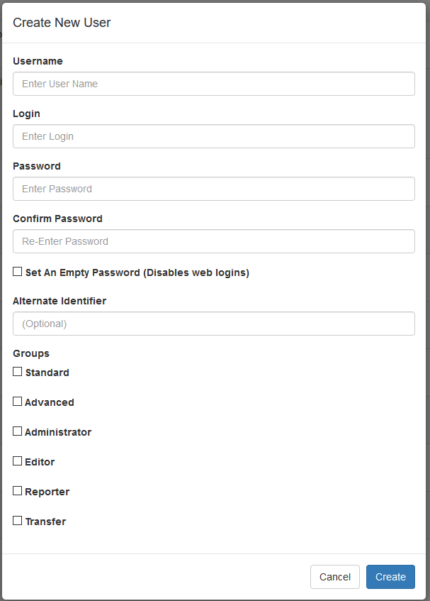
Create User

Editing and Deleting users
You can modify everything about a specific user (you can only modify the password on the admin user, however). Click on the Action dropdown user you wish to edit. From here you’ll be given options to Change Password, Change Names, Change Groups, or Change Image for the given user. This same dropdown is user to Delete users which moves them to the Recycle Bin.
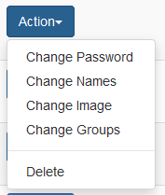
Edit User Dropdown

Viewing Inspections

Inspection List
A list of each individual inspection uploaded to the data server can be viewed from the inspections page. This can be accessed by clicking the Review Inspections link on the homepage or by the Inspections link on the navbar at the top of most pages. From this page, you will be show the most recent 20 inspections.
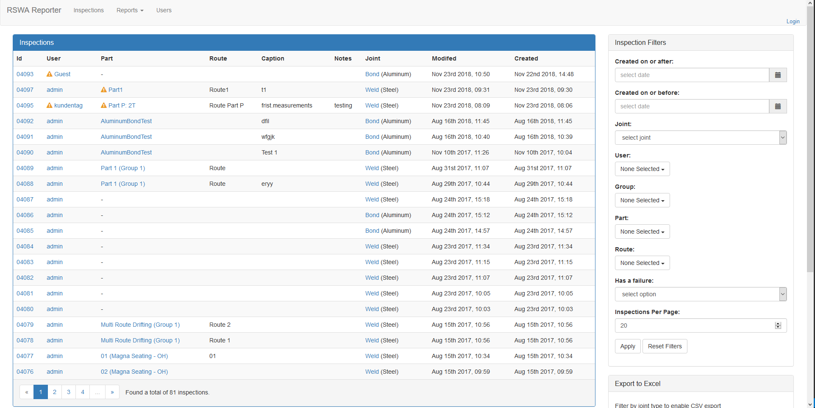
Inspections
The main portion of the screen contains the inspection list. Each entry in this list (if any) contains a brief description of the completed inspection. It contains the User that made the inspection, the Part, Group, Route, Caption and Notes if any, the Joint type and material measured, as well as the date and time the inspection was created and last saved. If the part or user associated with an inspection is no longer present in the server, an exclamation mark will be shown next to the respective detail. If more inspections are present on the server than the list can hold, you may use the buttoms on the bottom of the list to jump to different pages of inspections.
On the top-right hand of the screen a list of options for filtering inspections by a variety of criteria is available. You may filter by the created dates, joint type user that performed the inspection, the group, part, and route that was measured, and if the inspection contains a failure. You can also set the number of inspections you’d like to have appear in a page. To apply the set filters press the Apply button. If you would like to remove all active filters, you may use the Reset Filters button.
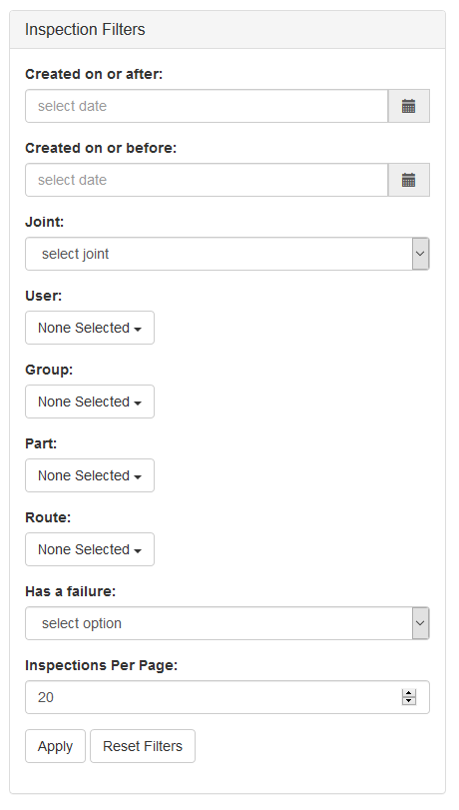
Filters

Bulk CSV Export
If you filter by Joint type, you may also export inspection details to Comma Seperated Values (CSV) format from the dialog in the bottom- right hand of the screen. A preset format for the data must first be selected (more on reviewing and editing presets later). You may also opt to export the data with column headers by clicking the nearby checkbox as well. Once the preset has been selected, a series of checkboxes will appear next to the inspections in the list. Select each individual inspection you’d like or use the checkbox at the top to toggle selecting all or none of the inspections. Once you’ve made your choices use the Export button to download a single or zip of CSV files that can be imported into Microsoft Excel.
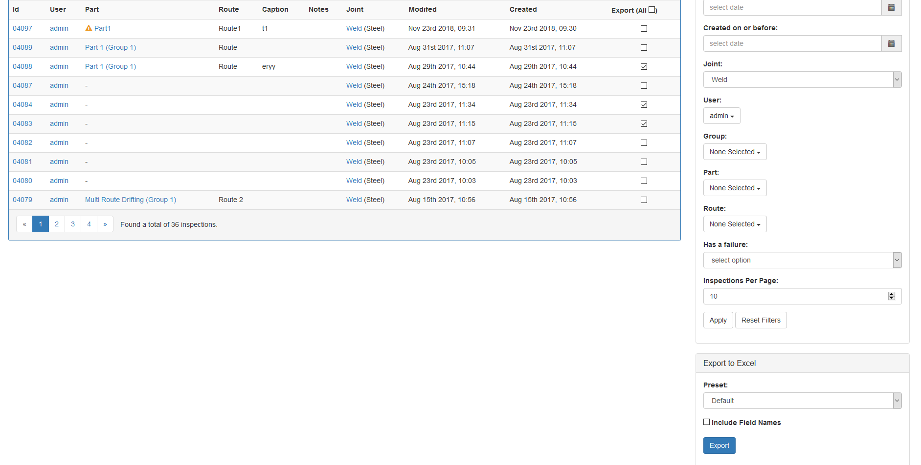
Bulk Export

Inspection Details
To view the details for an inspection click the Id number for it on the left hand side. From here you can see the main Details of the inspection such as the User who performed it, the Device Id of the RSWA the inspection was performed on, the Created and Modified date and times, the Name of the inspection, the Notes for the inspection, and the Part and Route inspected if any.
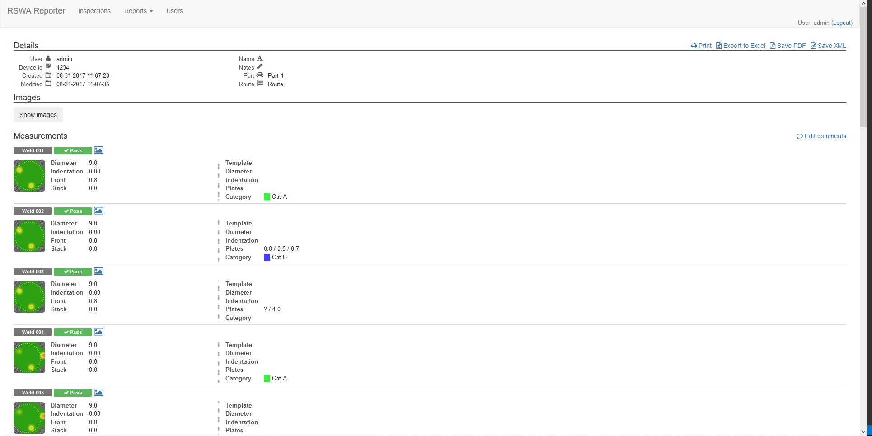
Inspection Details
At the top right is a set of options for exporting inspection data. You may choose to either Print the page, Export to Excel, Save PDF or Save XML. Print will activate printer options for a printer friendly view of the current page. Export to Excel will send you to the preset selection page for the current inspection (more on that later). Save PDF will prompt you to save the current page as a .pdf document. Finally, Save XML will take you to an .xml readout of the page data which you can save manually.
Underneath the Details section, if the inspection being viewed is for a part with images, there’s the Images section. Press the Show Images button to expand this view to show all images for the part. Clicking an individual image will bring up the image viewer. From this viewer you can see the location of each individual joint as specified in the template when it was created. You may mouse over the joints to highlight them, revealing their names. Alternatively, you may press Toggle Labels to reveal them all. You may use the mouse wheel to zoom in and out or the Zoom In and Zoom Out buttons respectively. Click and drag the image to pan it. Press the Reset View button to jump back to the original perspective. If the inspection is for a route, you may press Toggle Route to reveal an overlay of the route.
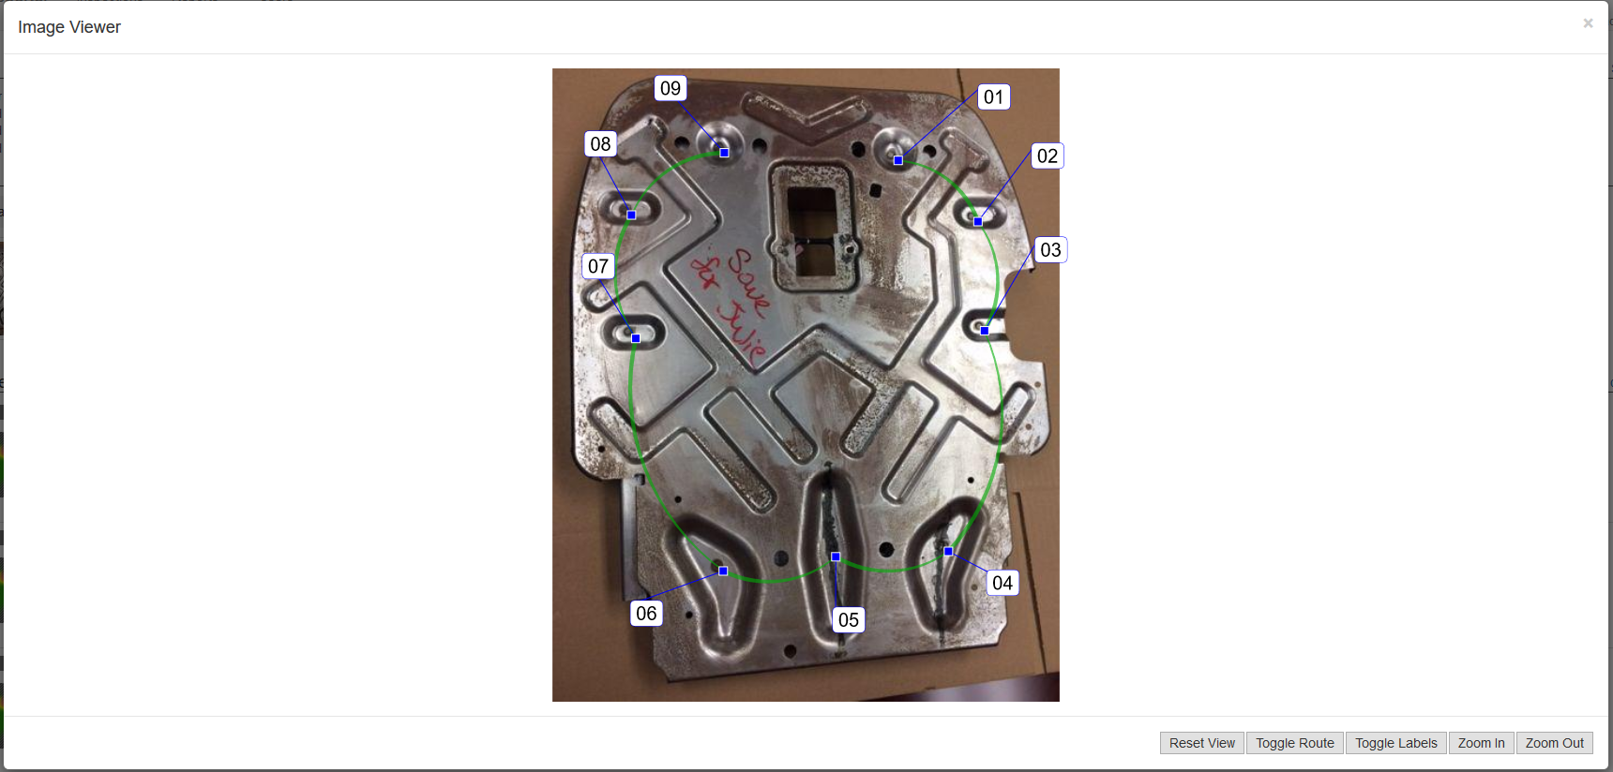
Image Viewer
The final section of the inspection details page are the individual measurements. Here you will see a readout of the details for each joint. This includes the name, operator’s descision, c-scan and bead overlay, measurement, and template data. You may click the small image icon to jump directly to the image viewer for that weld if appropriate. 3T welds will show two readouts in one row.

CSV Export
When accessing CSV Export via an inspection details page you will be prompted with a screen similar to this one.
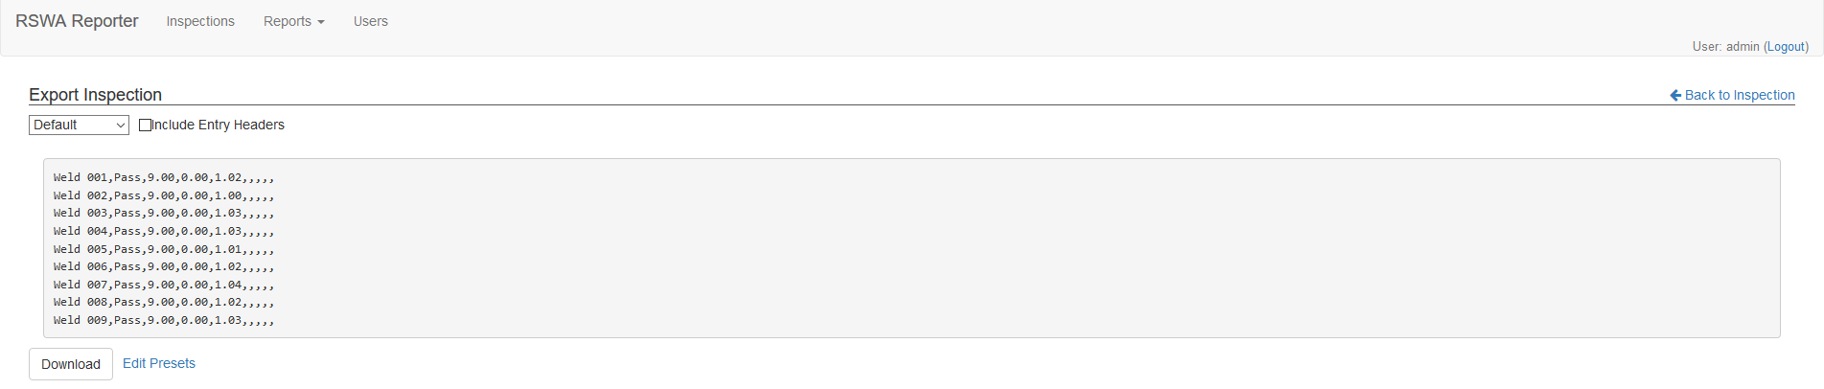
Preset Select
From here you can select one of the pre-created template formates to export the inspection data. The Include Entry Headers checkbox dictates whether or not column names will be included. The grey area shows a preview of the result file. To download the file, click the Download button.
If you are logged in as a user in the Editor group, you have the option to modify the presets. The Edit Presets button should be visible to you. Clicking it will take you to the preset editor for the current joint type. The page may also be reached from the bulk export menu on the inspection list page.
Preset Editor
From here you can Create, Edit, Rename, and Delete presets via the Action dropdown (The Default preset may only be edited). Each action will prompt you with a dialog containing further instructions.
The Edit dialog allows you to select which fields associated with each measurement are activated in the preset. Fields in the left column will not be shown, while fields in the right will be shown in order from top to bottom. Fields may be dragged to any cell in the table. You may use the Cancel button to exit without saving changes made. The Clear button will move all fields to the inactive column. When you are finished making changes. Press the Save button to persist them.

Viewing Reports
TDS offers a variety of reporting tools to help get a better understanding of your part failures and reasons for them as well as operator usage statistics.

Part Failure Reports
To view part failure reports, first head to the Product Overview report page. You may also access the page via the Reports dropdown in the navbar by clicking the Product Overview link listed there. This page lists the overall inspection statistics for all Parts in every Group ever entered in the database. These statistics include the total number of Inspections, Measurements taken, and how many of them were Failures. The first entry will always be for custom inspections made on the RSWA. Due to the nature of these types of inspections, no further data can be provided. The Change Dates dropdown may be used to lessen the timespan shown. To view the details for an individual group, the Group names in the leftmost column may be clicked.
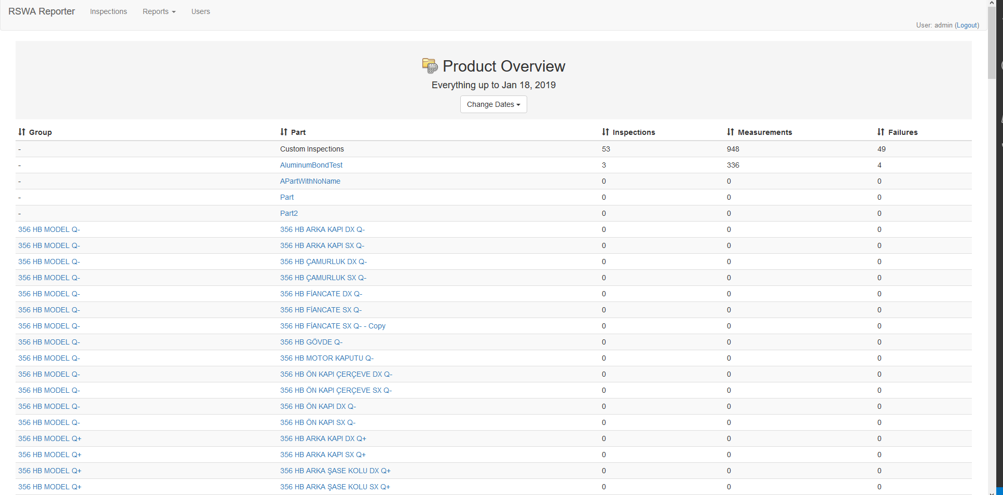
Product Overview
When a Part name is clicked, the details page for that part is opened. This is very similar to the inspection details page for an inspection of that part. You may use the Filter Names dialog to show only a subset of the joints in the part. As before, the Change Dates dropdown may be used to lessen the timespan shown. For each individual joint, next to the image viewer icon, there is a report graph icon. Clicking this loads a graph plotting the data for each measurement made in the given timespan. The remaining details are that of the template parameters for the part as well as the Measurement and Failure statistics.
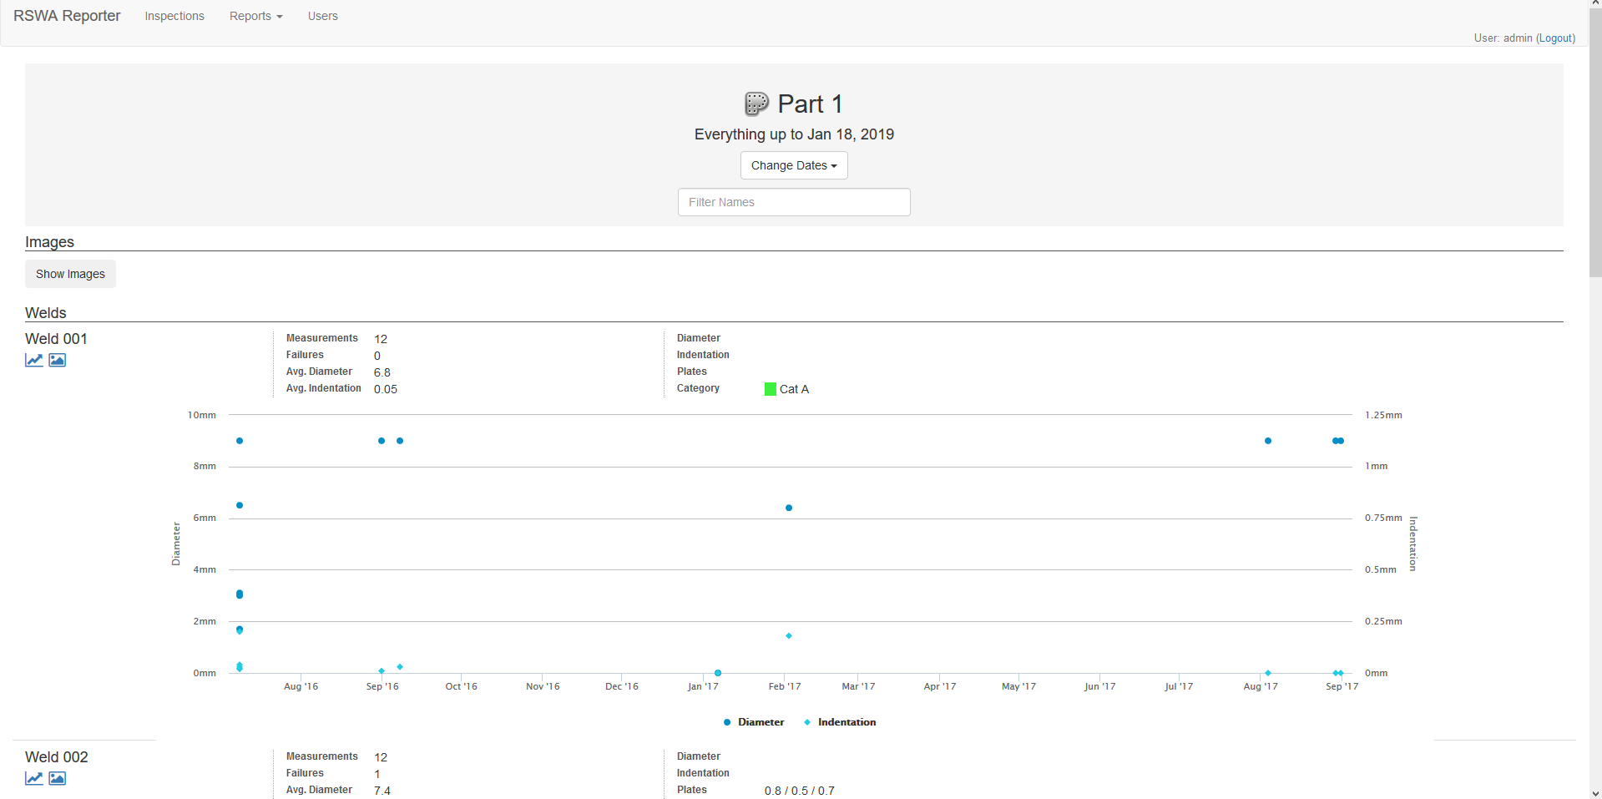
Part Report

Reason Usage Report
To view decision reason reports, first head to the Reason Usage report page. You may also access the page via the Reports dropdown in the navbar by clicking the Reason Usage link listed there. This page lists reasons for passing or failing a given measurement during an inspection. At the top of the page, you will see filter options for modifying the results. You may change the given date range, switch between viewing the reasons for Welds and Bonds, as well as viewing Pass and Fail reasons, or both via the All option. The Show Custom Reasons checkbox will change how reasons entered at inspection time by the operator are displayed. If unchecked, they will be grouped together under the ** Other Pass entry. Otherwise, there will be an entry for each unique instance. You will be shown a bar graph and pie chart of the reason counts and percentages for the given filters. Below that you will see the exact count for each reason. Reasons that have been deleted from the data server will appear as ** Deleted Pass or ** Deleted Fail.
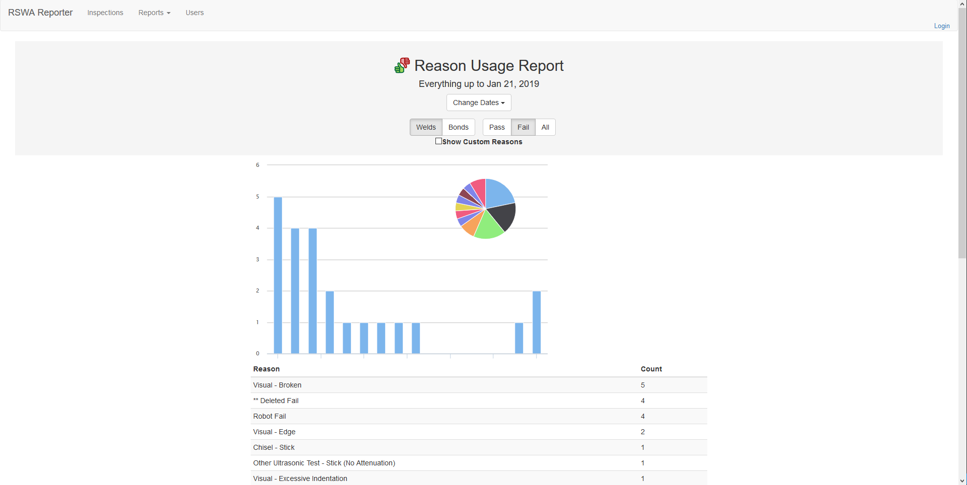
Reason Usage

Operator Usage Report
To view decision reason reports, first head to the Operator Usage report page. You may also access the page via the Reports dropdown in the navbar by clicking the Operator Usage link listed there. This page lists reasons for passing or failing a given measurement during an inspection. At the top of the page, you will see filter options for modifying the results. You may change the given date range, switch between viewing the report for Welds and Bonds, or both via the All option. You will be shown a bar graph and pie chart of the measurement counts and percentages for the given filters. Below this graph, in the entry list, you can see the exact details for each user in the data server. Clicking on their name will send you to the inspection list with the current filters for that user.
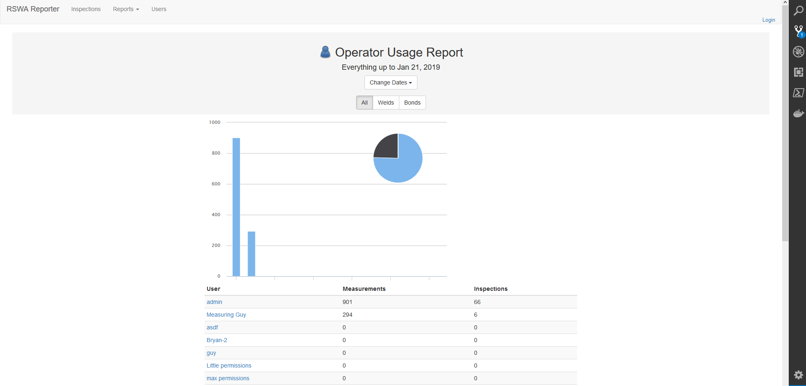
Operator Usage

